**INFORMATION MANAGEMENT**

**Exercise 11**

1. Count the number of employees who have been with Bignet for four or more years.

SELECT COUNT(*) FROM employee_data WHERE yos >= 4;

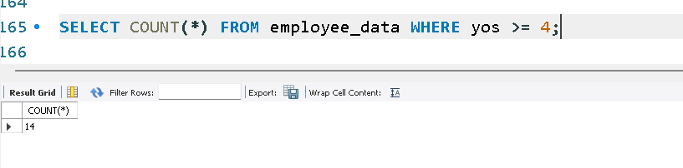

2. Count employees based on their ages.

SELECT age, COUNT(*) FROM employee_data GROUP BY age;

